About Linus shell commands
32202733 HyunTaek Oh

- pwd
- “pwd” command is used to print the information of the currently working directory.
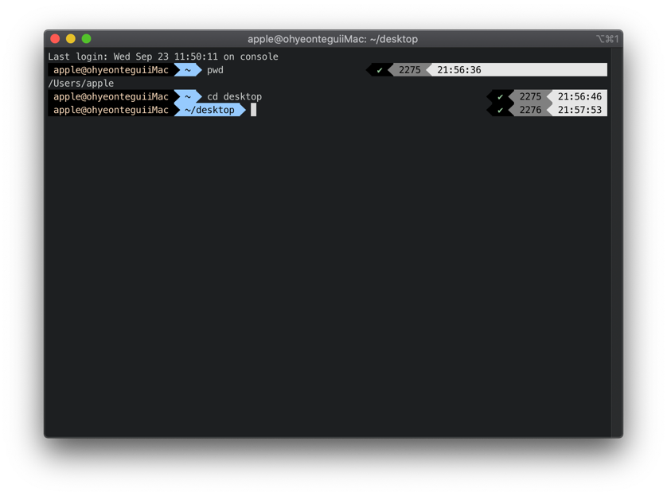
- cd(change directory)
- “cd” command is used to move the path of directory.
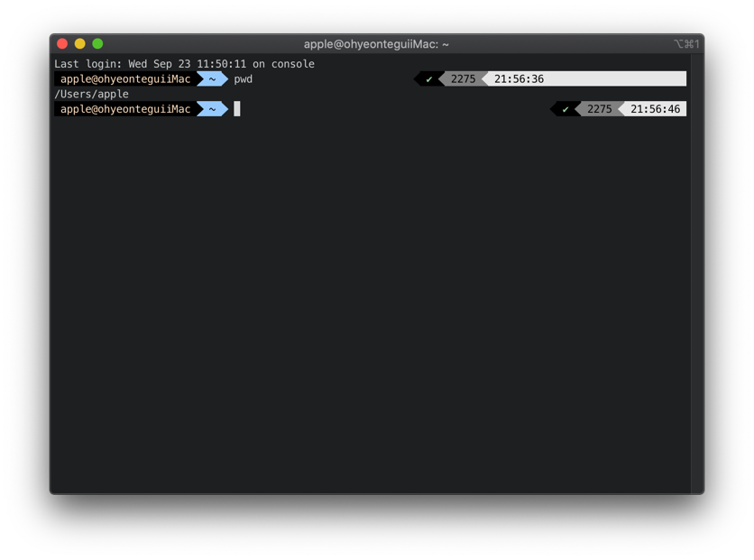
- ls(list)
- “ls” command is used to find the list of directories.
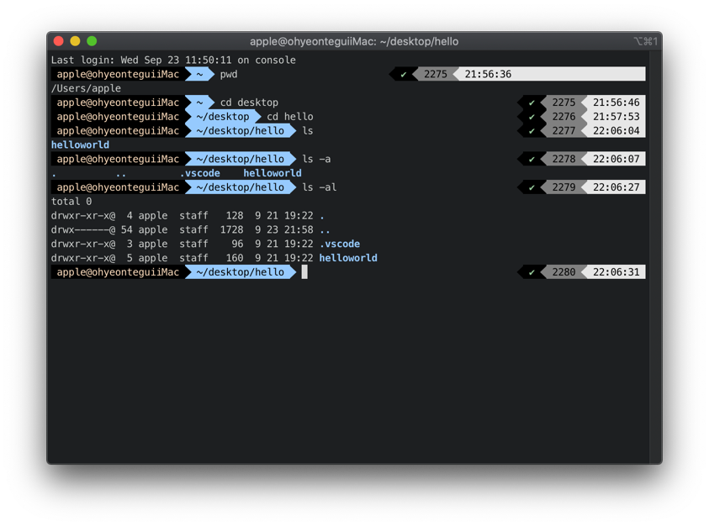
- cp(copy)
- “cp” command is used to copy file or directory.
- If to copy the directory, we need to give “-r” option to the command.
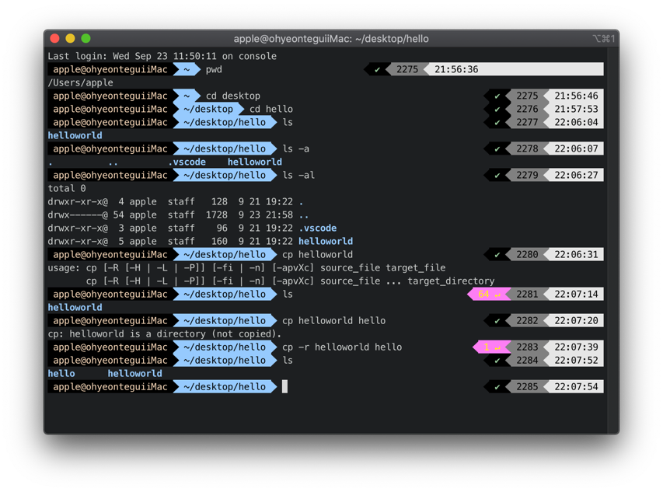
- mv(move)
- “mv” command is used to move the file or directory or to change the name of the file.
- To move the directory, mv command doesn’t require any options.
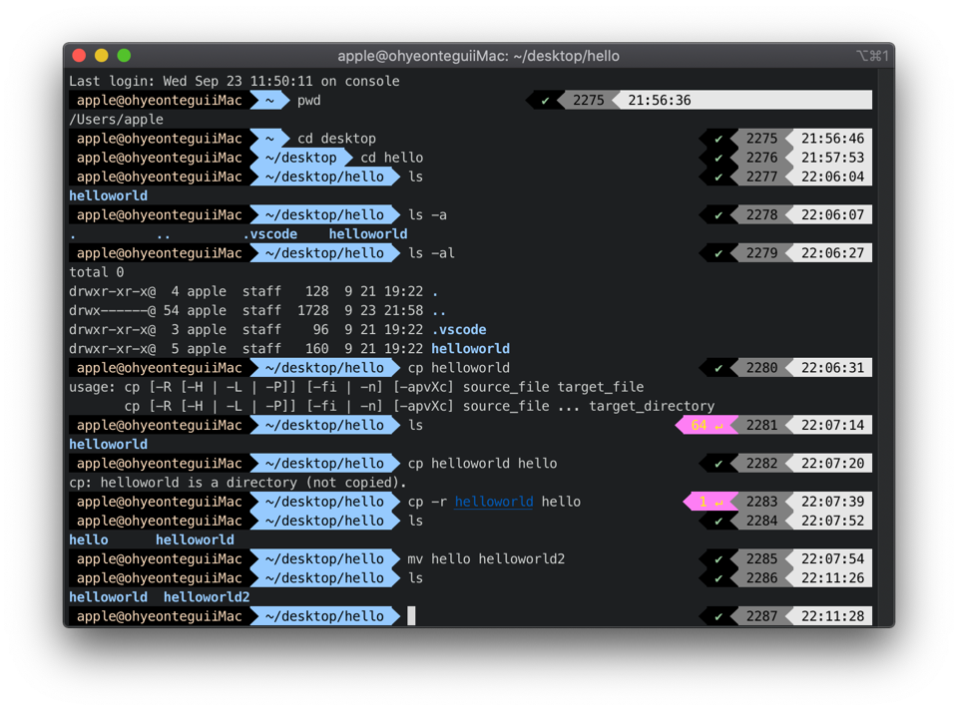
- mkdir(make directory)
- “mkdir” command is used to create the directory.
- By using “-p” option, we can make down directory by once.
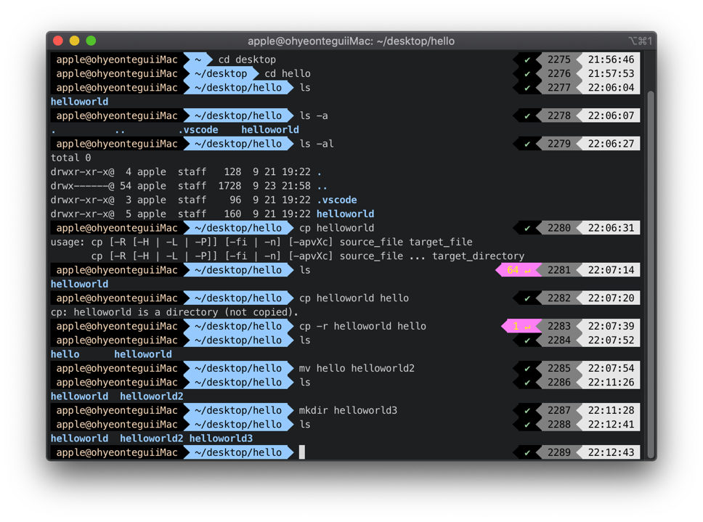
- rm(remove)
- “rm” command is used to delete the file or directory.
- If we want to delete directory, we need to use option “-r”.
- By using “-f” option, we can delete the file without confirm.
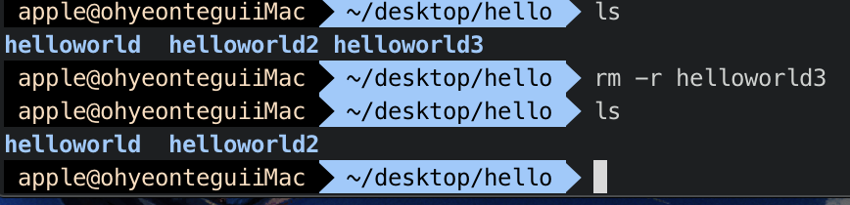
- touch
- Change the recent update time of the file or directory to current time.
- If the file or directory doesn’t exist, make an empty file.
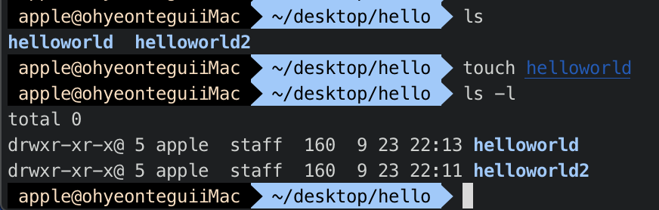
- cat(concatenate)
- “cat” command can be use in various ways.
- We can use cat command just to print the value of the file, combine several files into one file, and can make new file.
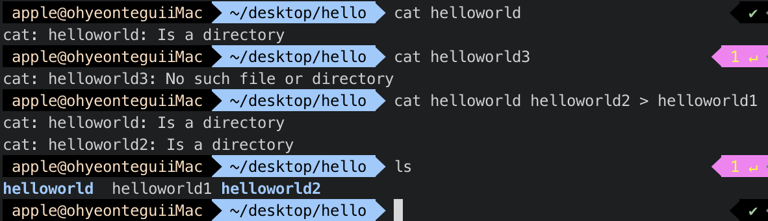
- head
- “head” command show the value of the file from top to bottom.
- Without option, the command will show the value of file from top to 10.
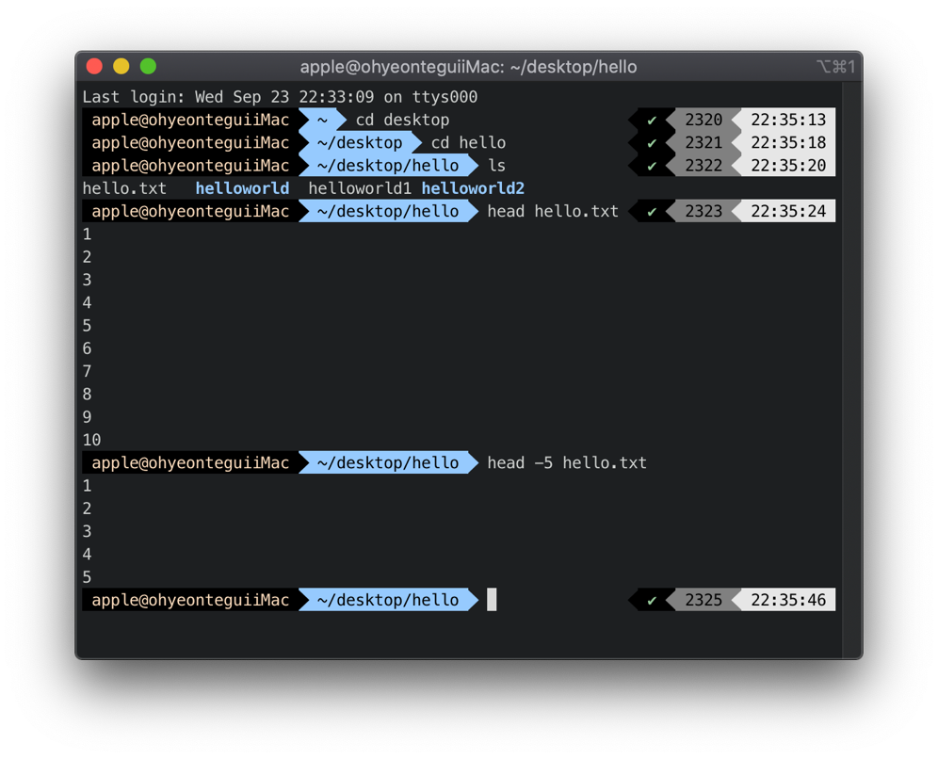

- tail
- “tail” command show the value of the file from bottom to top.
- Without option, the command will show the value of file from bottom to 10.
- With “-f ” option, we can update the updated value if the file has changed.
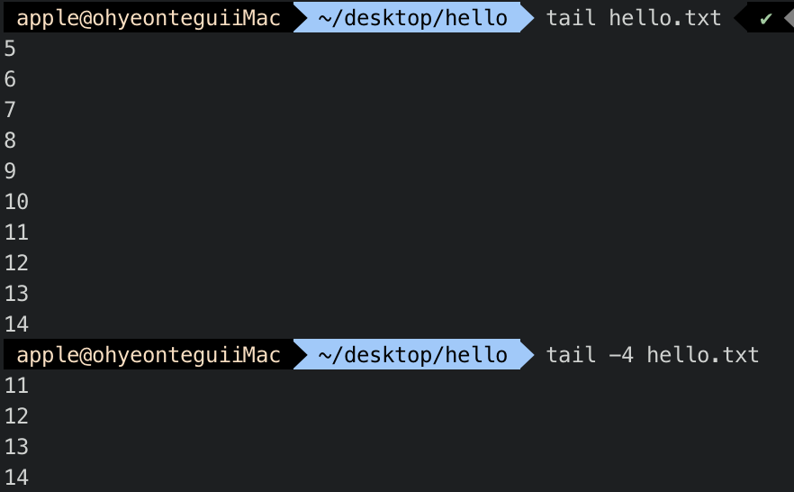
- find
- “find” command search the specific file or directory.
- We can use this command by “ find [path] -name[name of file]”.
